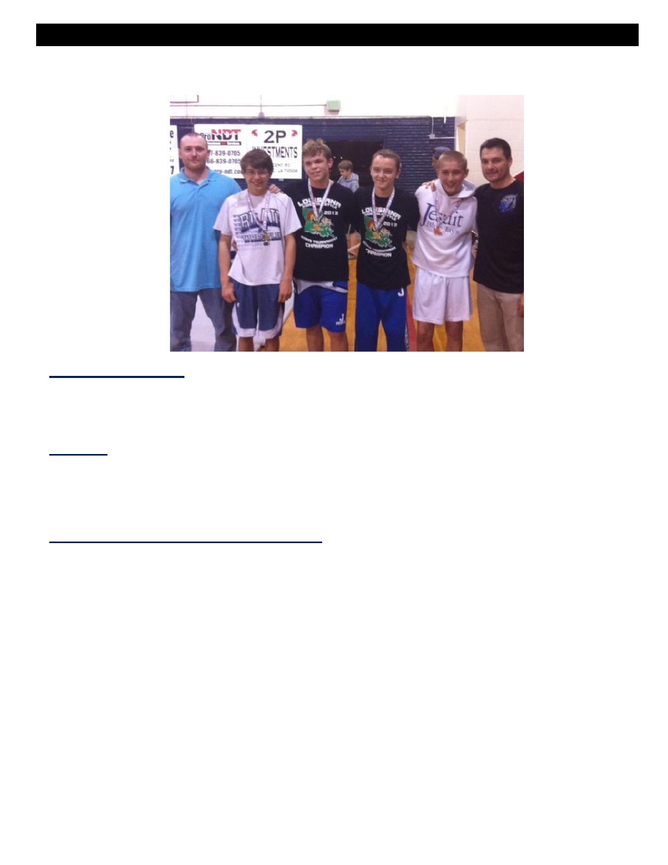
REGISTRATION FORM
THE BLUE JAY WRESTLING CAMP
.

To register, please return:

• Completed Registration Form
• Signed Waiver Release for Medical Treatment
• Payment - cash or checks payable to Jesuit High School

At t e n t io n :

G r e g g R om a n o , A ss is t an t W res t lin g H e a d C o ach
Jesuit High School 4133 Banks Street
New Orleans, LA 70119

Please print out all pages and fill out to be turned in:

Name of Camper: _____________________________________________________

Home Address: _______________________________________________________

Parent(s) or Guardian(s) Names: ________________________________________

Age: ________

Zip: ________

Phone Numbers: Home: ____________________________ Work: _________________________

Cell: ____________________________ Email: __________________________

Height: ___________________________ Weight: _________________________

School / Grade Attending for 2013 - 2014: ________________________________________________

Session (August 5 - August 8) - $125 per session - checks payable to Jesuit High School

Total Amount Enclosed: ______________

I hereby request that my child be admitted to The Blue Jay Wrestling Camp offered by Jesuit High School. I
understand that any camper who does not abide by the rules and regulations of the camp are subject to dismissal without reimbursement or recourse.

Parent/Guardian Signature: ________________________________________ Date: ____________


Waiver Release for Medical Treatment

Please complete this application carefully and fill out all of the information:
Name of Camper: ____________________________________________________
Date of Birth: _____________________ Age: _____
Health History: Please list ANY allergies, disease(s), medications, special needs, restrictions and / or limitations:

Emergency Contact Name: __________________________________________________________

Emergency Contact's Phone Number's: __________________________________________________________

Physician's Name: ________________________________________________________

Physician's Phone Number: _________________________________________________________

Parent/Guardian Authorization:
I hereby recognize and acknowledge that The Blue Jay Wrestling Camp does not carry special health and/or hospital
insurance and I will provide special insurance coverage for my son in the event that he should sustain an accidental injury while participating in The Blue Jay Wrestling Camp activities. I further recognize and voluntarily assume on my behalf and on behalf of my child and/or ward. By my signature below, I hereby voluntarily agree to release, hold harmless and indemnify Jesuit High School (including those corporate entities which administer Jesuit or which otherwise are related to Jesuit and its officers, board of trustees, agents, servants, employees, members of the camp staff, and the director of the camp (hereinafter referred to collectively as Jesuit High School from all claims and causes of action of any nature whatsoever, whether such claim results from the negligence of Jesuit High School or from some other cause, which the undersigned and/or their heirs, assigns, or successors may have for or by reason
of applicant's participation in The Blue Jay Wrestling Camp. The undersigned specifically releases, holds harmless and agrees to indemnify, without limitation, Jesuit High School from any and all liability for any personal injury or death to the applicant, or from any damage or loss of property which may arise from or be incident to the applicant's participation in The Blue Jay Wrestling Camp, and further waives any and all rights, claims and causes of action which may arise from or be incident to such participation. I hereby authorize The Blue Jay Wrestling Camp to act for me according to their best judgment in an emergency requiring medical attention for the applicant. My son is physically fit and according to his physician, has no physical limitations preventing his participation in the activities of The Blue Jay Wrestling Camp.

Parent/Guardian Signature: _______________________________________________Date: ______________

JESUIT HIGH SCHOOL
4133 Banks Street, New Orleans, LA 70119 • 504.623.5715 • romano.gregg@yahoo.com

